Name: Hata Milišić
E-mail: hata.milisic@gmail.com; hata_bandic@gf.unsa.ba
Institution: Faculty of Civil Engineering in Sarajevo, University of Sarajevo
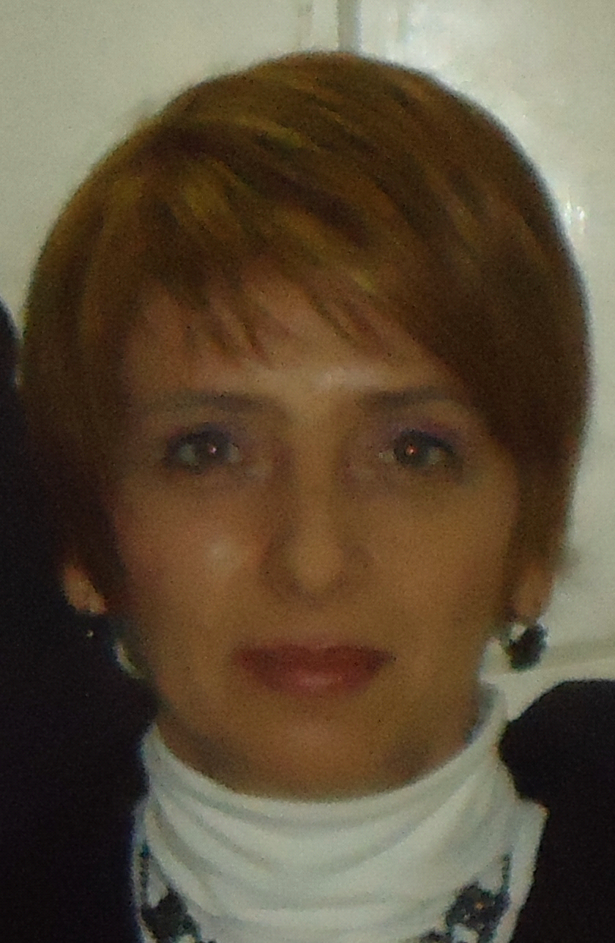 | Hata Milišić received her diploma as Civil Engineer, Dipl-Eng. in 1998 (Faculty of Civil Engineering, University of Sarajevo). In 2012 she received her MSc diploma (University of Split, Faculty of Civil Engineering, Architecture and Geodesy) and in 2017, she recived her doctoral degree, in the field of technical sciences (University of Sarajevo). She has over 18 years of extensive experience in the field of of fluid mechanics, river hydraulics engineering, hydrodynamics of groundwater and water supply and sewage. She has worked almost entirely on the management, design and supervising of water protection and environmental protection projects, flood analysis, as well as on hydrodynamic aspects of ecological problems of water resources, environmental impact assessment, water quality monitoring analysis and water quality modelling.  She is a full time employment at the University of Sarajevo – Faculty for Civil Engineering as a Senior Scientific Assistant for academic fields: Water Resources and Environmental Engineering.  She is a member of many professional and scientific associations and has published several scientific papers.
References (max. 5 relevant references)
- Milišić H.," Predviđanje koeficijenta uzdužne disperzije u prirodnim vodotocima na osnovu mjerenja ADCP uređajem" – Časopis "VODOPRIVREDA", Beograd, Srpsko društvo za odvodnjavanje i navodnjavanje, 2015., 0350-0519, Vol. 47 (2015) No. 276-278 p. 243-252.
- Hadžić E., Milišić H., Lazović N., "Jednodimenzionalno modeliranje kvaliteta vode rijeke Lašve" – Časopis "VODOPRIVREDA", Beograd, Srpsko društvo za odvodnjavanje i navodnjavanje, 2015., VODOPRIVREDA 0350-0519, Vol. 47 (2015) No. 273-275 p. 111-118.
- Milišić H., "Transport processes in rivers modelling using field experimental data", 7th IWA Eastern European Young Water Professionals, CONFERENCE PROCEEDINGS, THE INTERNATIONAL WATER ASSOCIATION (IWA) - Belgrade, Serbia, 17.-19. 09. 2015., p. 138-145.
- Milišic, H., Hadžić, E., Lazović, N.,"Application Modeling and assessment of water quality in a natural rivers", 2nd Int. Conference on Multiscale Computations for Solids and Fluids, June 10-12, 2015 - Sarajevo, Bosnia and Herzegovina.
- Milišić H., Kalajdžisalihović H., "Pollutant dispersion modelling in natural rivers", 5th IWA Eastern European Water Professionals Conference for Young and Senior Water Professionals, - CONFERENCE PROCEEDINGS, THE INTERNATIONAL WATER ASSOCIATION (IWA) - Kiev, Ukraina, 26.-28. 06. 2013., str. 127-134.

Project number: 573806-EPP-1-2016-1-RS-EPPKA2-CBHE-JP

"This project has been funded with support from the European Commission. This publication reflects the views only of the author, and the Commission cannot be held responsible for any use which may be made of the information contained therein"

